CHARITY PRESENTATION 2011
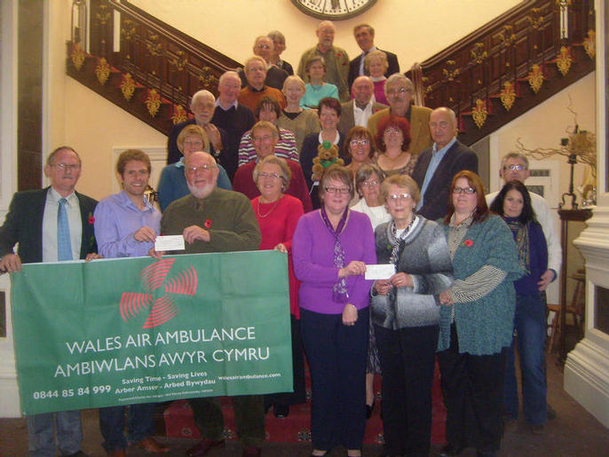
The club presented two cheques of £300.00 each to the Air Ambulance and the MacMillan Nurses Fund, the chosen charities of the club. The presentation was held at the Norton Manor Hotel, Presteigne, on Sunday 6th November 2011.
Pictured presenting a cheque to Peter and Jo Tonks the representatives from the Air Ambulance is Darren Jarmen - Managing Director of Lowfield Timber Frames, who sponsored one of the classic car events and Bob Garforth - Chairman of Knghton Historic Vehicle Club.
Also pictured presenting a cheque to Liz George of the MacMillan Nurses is club member Rachel Vaughn and Karyn Myatt - Editor of the clubs newsletter.

