|  |
| --- |
| **PHOTO GALLERY - TRIP TO FRANCE OLD CROCKS TOUR TO FRANCE 2008** |

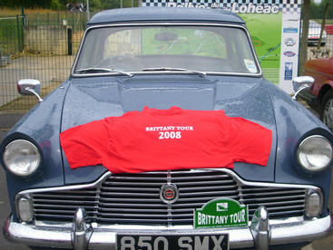

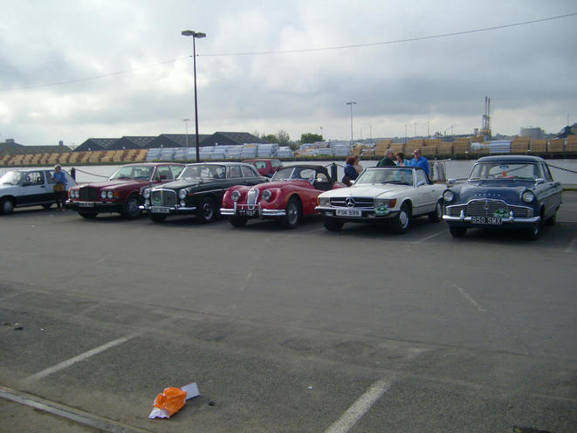

LINED UP READY TO GO AT ST MALO

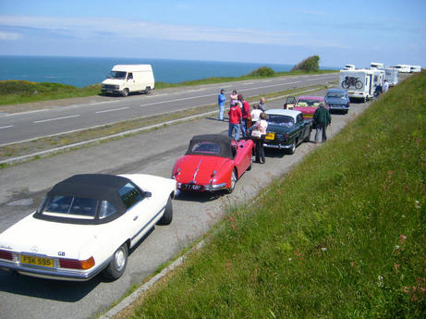

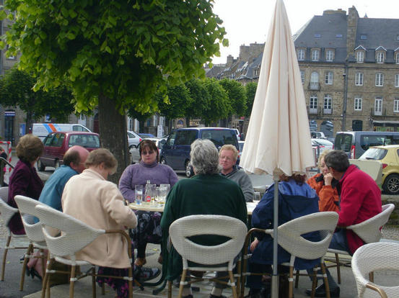

ENJOYING A BEER IN DINAN

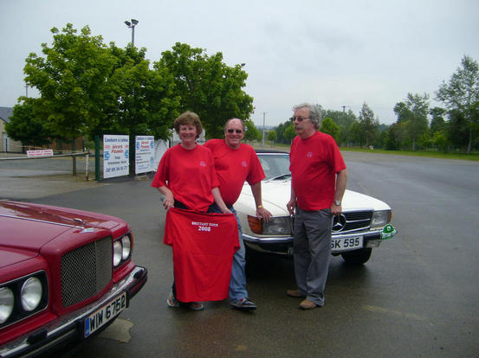

LENNY MIRIAM AND MARTIN WITH THE TOUR T-SHIRTS THEY KINDLY PROVIDED

***MEMBERS CARS***

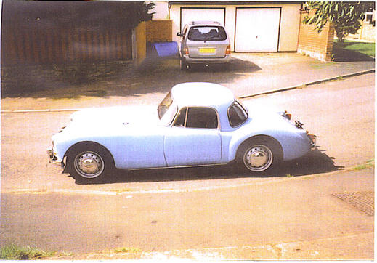

A 1959 MGA 1600

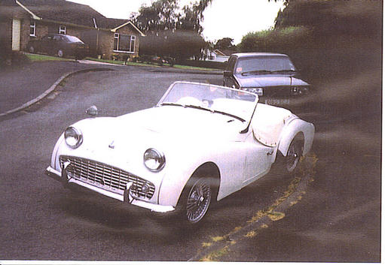

A 1960 TRIUMPH TR3 A

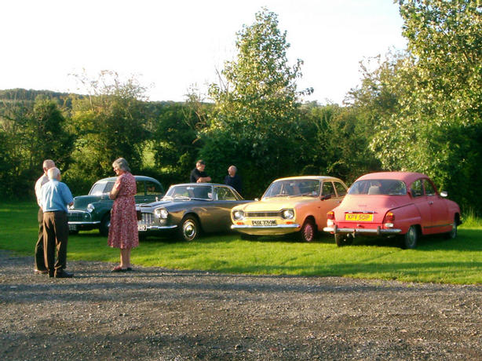

CLASSICS AT OUR AUGUST CLUB NIGHT AT THE ENGINE AND TENDER AT BROOME

